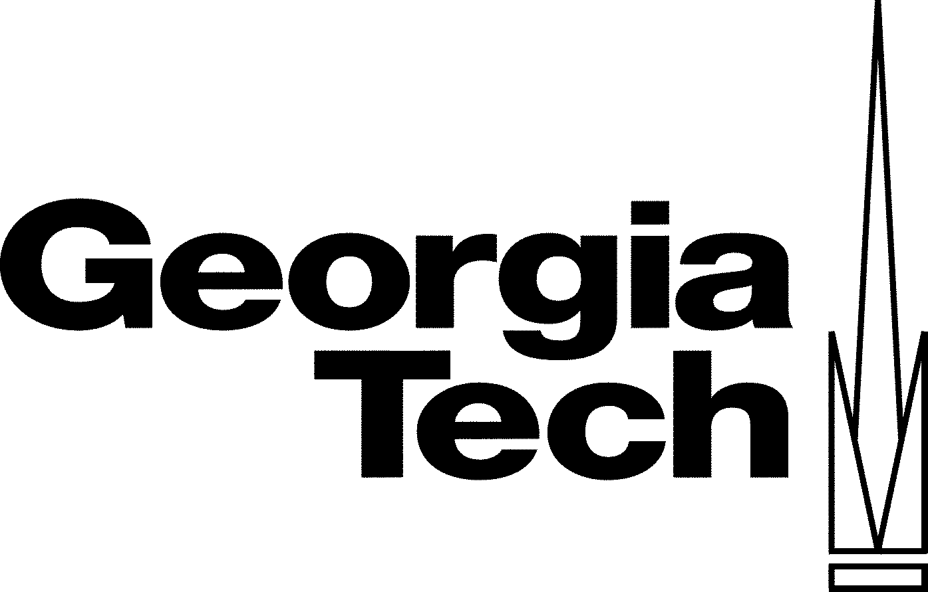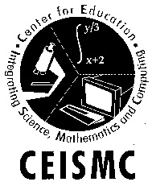Needs Assessment

Goals/Objectives

- Through my summer experience, I would like to further develop my research relationship with my mentor, and the graduate students working in his lab. Develop additional opportunities to bring a group of students to the Geochemistry lab for micro-research projects/labs.
- Develop a better understanding of the processes and systems being studied within the Geochemistry lab. As well as, learning more about the career options available to students conducting research within this department.
- Creating a handbook of lab methodology for high school chemistry students based on the instrumentation and analyses I have learned to use this summer. Many of the procedures are adaptable and applicable to the General Chemistry curriculum.
- Explore Georgia Tech admissions options for minority students and make contact with the Minority Admissions Director on campus.

Student Needs

The following are the areas in which my students demonstrate the greatest needs for improvement:

- The ability to take quantitative data generated from class lab experiments and construct graphic representation of such data using computerized spreadsheet applications.
- The ability to define and solve conceptual (real-world) problems using prior and acquired knowledge. In addition, being able to conduct background research and develop experimental plans for evaluating conceptual problems.
- The ability to effectively use basic software applications (i.e., Microsoft Word, Excel and PowerPoint) in the production of research presentations.
- The ability to multi-task. (Manage more than one assignment with overlapping deadlines) TIME MANAGEMENT

Constraints

I am moving to a newly established school this year, Miller Grove High School, in DeKalb County. The anticipated demographics of the student population are very similar to my previous school, Stone Mountain High School, 87% African American and the remaining 13% are Caucasians, Hispanics, Asians, and other nationalities. I feel the greatest challenge I face in the implementation of my action plan is student motivation. Many of the students with whom I have worked want to learn for the moment and not the lifetime. (In simpler terms, they want to pass the test and move on to the next chunk of information they are asked to learn). Lifelong learning is much more intrinsic and unfortunately many of my students would prefer more tangible motivators.

Teaching Method Changes

- Provide more experiences for students to apply key concepts to real-world application problems.
- Build on concepts from one unit to the next in my lesson planning. Finding current articles and news clips that show the students the relevance in what they are studying.
- Integrate more thought-provoking demonstrations into unit lesson plans.
- Integrate technology – software applications, calculator based labs, internet resources, etc. – as a mechanism for diversifying instruction.

Learning’s from Summer Experience

The following are things I anticipate learning this summer:

- Proper use and application of the Graphite Furnace for Flame Atomic Absorption analysis
- Use and integration of the statistical data analysis software, Origin.
- How to develop depth and geochemical profiles for creeks based on physical and chemical analysis.
- How to coordinate and facilitate a student-centered research project on a major college campus.

Concepts to Teach Better

- Properties of matter (beyond the basic introductory information)
- Mole concepts – stoichiometry, molarity, etc.
- Bonding – ionic, covalent and metallic
- Catalysis

Student Equity

Student equity is an integral part of my implementation plan. I will use a variety of teaching strategies to address all learning styles. I plan to conduct pre-assessments to determine the specific needs of students prior to our starting a new unit of study. In addition, I will include articles, videos and other media to foster a multicultural learning environment.

PERSONAL VISION OF CLASSROOM

Though it is difficult not to think of “high-stakes testing as the “end-all” to a year’s worth of teaching, I have found it to be a driving force in what I teach. Teachers are really being pressured to only think about standardized testing. In my classroom, I dare to step beyond the status quo. My classroom has been one in which I have tried to implement “one of a kind” ideas that will ignite my students’ passion for science. I have not been afraid to push the envelope with my students forcing them to think “outside of the BOX”. I do, however, realize that with accountability and standardized test scores being at the forefront of educational reform, I must insure that all of my students grasp the basic skills needed to be successful beyond my classroom.

My goals in the upcoming school year to present my lessons in a way in which students are continuously refining their basic skills and becoming more scientifically literate. By diversifying both instructional and assessment strategies, all learning styles will be addressed and provided every student multiple opportunities to experience success. I plan systemic exposure to alternative assessment strategies such as rubrics, portfolio projects, lab practicals, concept mapping and open-ended investigations promote learning in this diverse learning environment. I believe when students have ownership in their learning they are more likely to succeed.

The National Science Education Standards state that students in high school should develop the “abilities to characterize science as inquiry.” This would include active participation in scientific investigations and being able to use cognitive and manipulative skills associated with the formulation of scientific explanations. I believe that the processes and analyses I have learned in the EAS Geochemistry lab are applicable to various aspects of the curriculum I teach. I realistically foresee being able to use this information in providing students with real-world applications. Many of the lab analyses that this group uses can be modified for use in the secondary chemistry class. I plan to definitely implement an instrumentation unit to introduce students to colorimetric methods, titrations and atomic absorption spectroscopy. I know that the submersive approach will allow me to address more one than of the student needs listed above.

