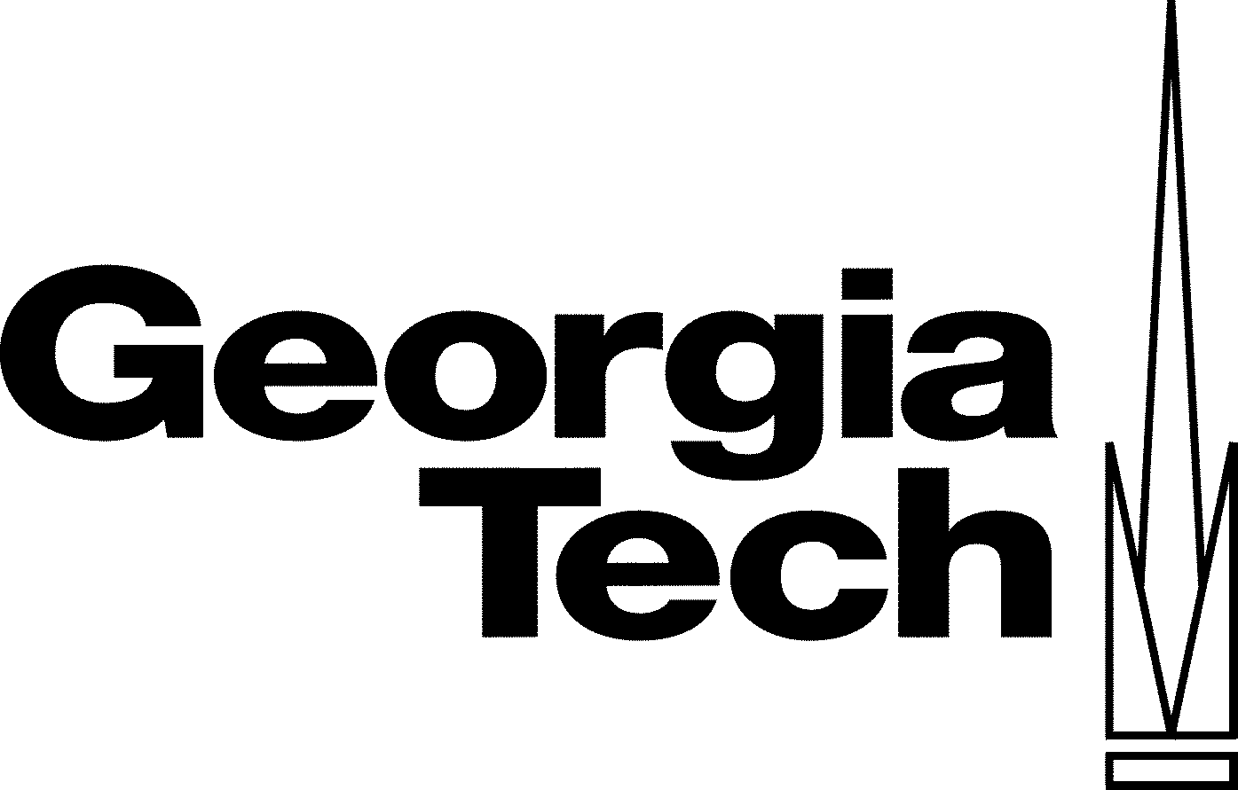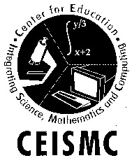Portfolio

Fellow: Solona Hollis
Mentor: Dr. Martial Taillefert
Job Location: Geochemistry (EAS)

Portfolio:

Resources

- American Chemical Society SourceBook 2.1 Volumes 1-4

This collection of binders addresses over 40 topics in chemistry. Every topic summary includes lab activities, cross-curricular references, and real-world applications for each concept. I plan to use this as a supplement to the textbook currently being used for the General Chemistry course.

- Twenty Demonstrations Guaranteed to Knock Your Socks Off Vols 1-2
By: Bob Becker

These books are designed to take the guess work out of doing demonstrations.
Many of the demonstrations are for chemistry and they use household items. I will be teaching on a 90-minute block schedule this year and would like to implement more demonstrations in my style of teaching.

- Chemical Demonstrations Vols. 1-4 By: Bassam Shakhashiri

Another resource for demonstrations covering over 60 concepts in Chemistry.
I will also use these as resources in preparing for my classes this fall.

- Thinkwell Chemistry
A virtual chemistry textbook with video demonstrations and animations of various concepts. I am particularly interested in using this as a supplemental resource for covering various topics with both my Chemistry and Physical Science classes.
- Standard Deviants Chemistry Survival Kit
A collection of three videos that include short skits to introduce and reinforce various concepts in chemistry. I will most likely use this resource for sponge activities and reviews for tests.

Flinn Scientific Foundation – Summer Chemistry Workshop at the University of Southern Mississippi in Hattiesburg, MS

I had the opportunity this summer to spend a week with 40 chemistry teachers from across the country. Each delay we participated in various lab activities and constructions. Many of the activities for make and take labs – where we built equipment for use in you classrooms. As a culminating activity, each teacher presented their favorite chemistry demonstration. It was very refreshing to hear other chemistry teachers express similar concerns about the quality of students, parental involvement, and curriculum.

DNA Forensics for High School Teachers – Clayton State University

I also attend a week along workshop at Clayton State University on DNA Forensics. I thoroughly enjoyed this workshop because the presenters made direct correlations to the QCCs and where the activities would be most applicable. I have integrated parts of forensic applications into the curriculum as appropriate.

